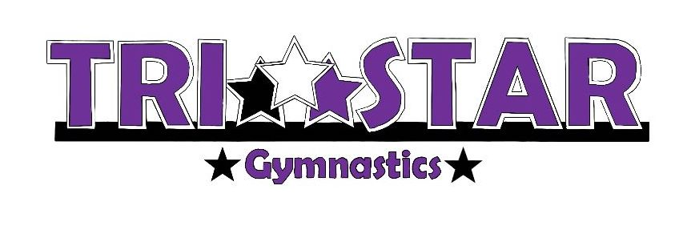
Year:
____2021-2022
____2022-2023
____2023-2024

Registration & Release Form
STUDENT INFORMATION |  |  |  |  |  |  |  |  |  | Male Female
Name |  |  |  |  |  |  |  |  |  |  | Home Phone
Address
 |  | Street |  |  |  |  | City |  |  |  |  | State |  | Zip
Age |  |  | DOB |  | Grade |  | School

PARENT INFORMATION
MOTHER |  |  |  | Home Phone
Address
 | Street |  | City |  | State |  | Zip
Work Phone |  |  |  | Cell Phone
Email
FATHER |  |  |  | Home Phone
Address
 | Street |  | City |  | State |  | Zip
Work Phone |  |  |  | Cell Phone
Email

BILLING INFORMATION
Name |  |  |  | Home Phone
Address
 | Street | City |  |  | State |  | Zip

PROGRAM INFORMATION
Client No:

_______________
Office Use Only

Class |  |  |  |  |  | Day |  |  | Time
Registration Fee |  |  |  | $ |  | + Tuition |  |  |  |  | = Total Due
Auto Pay |  | Yes No |  |  |  |  |  |  |  |  |  | = Total Paid
How Paid | Check # Cash Credit Card T-shirt Rec’d Handbook Rec’d

How did you hear about us?
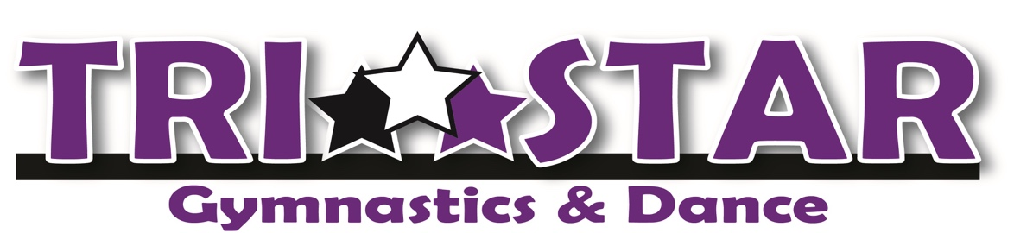
Registration & Release Form
I, the parent/guardian of |  |  |  |  |  |  |  | give permission for the Tri-Star Gymnastics Staff
to render simple first aid to my child in the event of any injury or illness, and if deemed necessary by the Tri-Star Gymnastics Staff to call a doctor and to seek medical help, including transportation by a Tri-Star Staff Member and/or it’s representative, whether paid or volunteered, to any health facility or hospital or the calling of an ambulance for said child should the Tri-Star Staff deem this to be necessary.
Any intolerance to drugs or medication? No Yes
If yes, please list:
Any previous illness or injury of which the staff should be aware? No Yes
If yes, please list:
If yes, are there any restrictions?
Are there any emotional issues, gross motor or fine motor skill issues of which our staff should be aware of? No Yes
If yes, please describe in detail: ____________
Any additional comments: __________________
Emergency Contact Information
If Mom or Dad are unable to be reached during an emergency, Tri-Star should contact:

Name: |  |  |  | Relationship: |  |  |  |  | Phone #:
Name: |  |  |  | Relationship: |  |  |  |  | Phone #:
Photo Image Release Form
PLEASE CHECK OFF THE ONE THAT APPLIES:
I give permission to HJK Sports, LLC dba Tri-Star Gymnastics to use my child’s image on the Tri-Star web site. I understand that I will not receive any type of compensation for the use of my child’s image.

I do not wish to have my child’s image posted on the Tri-Star web site.

Parent or Guardian Signature: |  |  | Date:
Tri-Star Gymnastics Waiver and Release Form
I fully understand that the staff members of HJK Sports, LLC – DBA Tri-Star Gymnastics, hereinafter referred to as Tri-Star Gymnastics, are not physicians or medical practitioners of any kind. With the above in mind, I hereby release the Tri-Star Gymnastics staff as to any temporary first aid rendered to my child or children in the event of any injury or illness, and if deemed necessary by the Tri-Star Gymnastics staff to call a doctor and to seek medical help including transportation by a Tri-Star staff member and or its representatives, whether paid or volunteer, to any health facility or hospital or the calling of an ambulance for said child should the Tri-Star Staff deem this to be necessary.
Parent or Guardian Signature: |  |  | Date:

We, the staff of Tri-Star Gymnastics recognize our obligation to make our students and their parents aware of the risks and hazards associated with the sport of gymnastics and tumbling. Students may suffer injuries, possibly minor, serious or catastrophic in nature including paralysis and even death. Gymnastics and tumbling can be dangerous and can lead to injury!
Parents should make their children aware of the possibility of injury and encourage their children to follow all of the safety rules and coaches’ instructions.
Tri-Star Gymnastics, its coaches and/or other staff members will not accept responsibility for injuries sustained by any student during the course of gymnastics, tumbling, or open workouts, or in the course of any exhibition, competition, or clinic in which he or she may participate or while traveling to or from the event.
With the above in mind, and being fully aware of the risks and possibility of injury involved, I consent ot have my child or children participate in the programs offered by Tri-Star Gymnastics. I, my executors or other representatives, waive and release any and all rights, claims and causes of action for any damages, including but not limited to personal injuries that I or my child or children may have against Tri-Star Gymnastics and/or its staff or other representatives whether paid or volunteer.
I also affirm that I now have and will continue to provide proper hospitalization, health and accident insurance coverage that I consider adequate for both my child’s protection and my own protection.
I also understand that it is the parents’ responsibility to warn the child about the dangers of gymnastics, tumbling, and other activities and the possibility of injury. I understand that it is my responsibility as the child’s parent to warn my child according to what I feel is appropriate. Tri-Star Gymnastics will only warn the child through “Safety Messages” and their teaching style and progressions.
Parent or Guardian Signature: |  |  |  | Date:
Witness:
Electronic signatures may be used to sign this agreement and shall have the same force and effect as an original signature. Electronic signatures are any letters, characters, or symbols, manifested by electronic or similar means, executed or adopted by an authorized signatory, with an intent to authenticate an agreement. An agreement is electronically signed if an electronic signature is logically associated with such agreement.

